|  |  |
| --- | --- |
|  | TRAJECTING NUCLER TECHNOLOGY TOWARDS SOLVING CHALLENGES IN AFRICA |

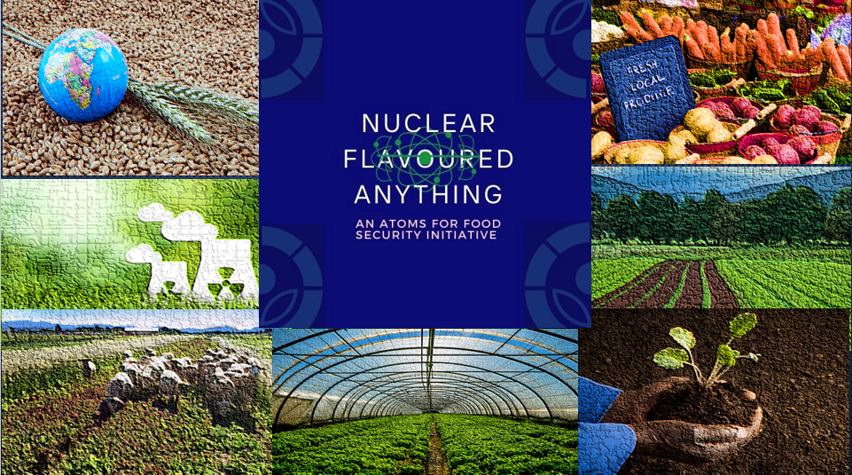

**TEAM KKV_REPUBLIC OF SOUTH AFRICA**



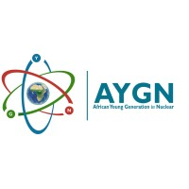

# EXECUTIVE SUMMARY

The "Nuclear Flavoured Anything - An Atoms for Food Security Initiative" is a comprehensive plan that aims to address the food security threats in South Africa caused by devastating rolling blackouts, commonly known as load-shedding. The initiative focuses on leveraging nuclear technology to preserve food, improve crop yields, and promote an eco-friendly farming culture in local farming communities. By working with small-scale farmers and large fresh food retailers, we aim to ensure national food security and drive global exports. The key projects under this initiative include food irradiation for preservation, irradiation of pre-sowed seeds greenhouse incubation, integrated crop-livestock farming coupled with Carbon-13 and Nitrogen-15 studies, and education and awareness campaigns.

## PROBLEM STATEMENT/RATIONALE

Now more than before food insecurity appears to be an imminent future for many vulnerable groups across the globe. Factors such as the rise in cost of living post covid-19 era, extreme weather conditions resulting in floods, draughts, poor crop yield and loss of life stock, and in South Africa an added woe locally referred as load-shedding. Rolling blackouts or load-shedding has become a national state of disaster affecting the agricultural production chain and causing significant losses in fresh food produce. In the past, about 10 million tons of fresh food have been lost annually, equivalent to a third of the country’s produce. With the added strain of increased frequency of load-shedding the figure is estimated to double over the next 5 years, and potentially risk losing half of the country’s food supply.

## FOOD IRRADIATION – A NUCLEAR TECHNOLOGY SOLUTION:

Food irradiation technology includes Gamma sources (Cs-137 and Co-60), X-rays and Electron beams. Gamma sources are used for irradiation technology globally, better penetrating power compared to X-rays and Electrons. Food irradiation using Co-60 has proven to be a reliable method of preserving food which has been commercially used for over 60 years in 40 countries. Gamma food irradiation facilities using Co-60 are well-established worldwide, including three facilities in South Africa's major cities. This technology can preserve staple foods like maize, rice, wheat, meats, fruits, and vegetables. Additionally, the benefits of irradiated food are to reduce spoilage, energy usage savings, and improved availability and quality, offset the production costs. Three ways in which irradiation extend the shelf life of fresh food are, by inhibiting sprouting, by delaying the ripening process of foods by slowing down the speed at which enzymes change food and destroys the microorganism in muscle foods (meats) that inevitably cause food to rot and decompose.

## PROJECT: NUCLEAR FLAVOURED ANYTHING – AN ATOMS FOR FOOD SECURITY INITIATIVE

According to the lasted UN Report, world hunger is on the rise, affecting nearly 10% of the global population. Over 800 million people are affected by malnourishment, while 40% of crop yields and millions of livestock are lost due to - pests, diseases and other climatic factors. These factors deviate the world from attaining Sustainable Development Goal 2, Zero Hunger, by 2030. Leveraging nuclear technology to **preserve food, improve crop yields, and promote an eco-friendly farming culture** in local farming communities can help put the world back on track for SDG2. The proposed initiative focuses on four key projects involving nuclear technology identified to achieve objectives of the project:

1. **Food Irradiation for Preservation:** The development of the Co-60 mobile truck irradiation facilities can be used as a series of mobile food irradiator to serve the supply-chain in small farming towns. These facilities will ensure convenient access for farmers while adhering to regulations concerning radioactive materials. By offering food irradiation services, we can help farmers and fresh food retailers preserve fresh produce, reduce spoilage, and ensure food security, especially during load-shedding.
2. **Irradiation of Pre-sowed Seeds Greenhouse Incubation Project:** Through this project, pre-irradiated seeds will be incubated and seedlings in greenhouses for local small-scale farmers and domestic farmers in the homelands to grow crops. The irradiation treatment will stimulate the initial growth process, destroy phytopathogens, and enhance crop yields. It will also promote resistance to diseases and unfavourable climate conditions, further securing food production.
3. **Integrated Crop-Livestock Farming Coupled with nuclear techniques Carbon-13 and Nitrogen-15:** To improve soil quality and reduce the reliance on artificial fertilizers, to promote integrated crop-livestock farming practices. By utilizing isotopes C-13 and N-15, ability to assess soil fertility and evaluate crop absorption efficiency.
4. **Education and awareness campaigns:** to recognize the importance of educating all stakeholders (importantly the consumer) about the safety and quality of irradiated foods. Our campaigns will target civil society, government agencies, private sector entities, farmers, retailers, food, and agriculture NPOs, and any other relevant stakeholders.

**DIRECT AND IN-DIRECT BENEFITS OF THE PROJECT:**

* Job creation and skills development in training Operators, RPO/Safety Officer, and others (packagers, maintainers, drivers). Radiation Safety courses and Industrial Irradiator Operator courses
* Economic development in the agricultural sector , empowerment of SMMEs Small-Scale Farming,
* Market to meet consumer demands for fresh, exotic, chemical free foods.
* Exports of local foods: The local export market of fresh food can grow.
* Sterilized foods for the vulnerable: A benefit for the vulnerable in our communities such as patients whose diet requires Bacteria free food.
* Minimize the annual food loss rate (10 million tonnes/year) to feed the needy masses and curb malnutrition.
* Non-commercial farmers irradiated seeds to grow food faster to feed their communities.
* Promoting eco-friendly farming.

## SMALL SCALE FARMING MARKET:

The agricultural sector is one of the most important economic development sectors that has potential for growth. The sector contributes 2.5-3 % to the GDP of RSA, compared to the world average of 10.35% GDP (TGE, 2023). Commercially in RSA, Large-Scale Farmers who are largely responsible for “national food security” are responsible for about 80% of the country’s commercial food market; Small-Scale Farmers play a role in “household food security” and contribute about 20 % to the commercial food market. For the past 23 years Small-Scale Farmers have been marginalised and not given enough opportunities to participate in the commercial food markets (Cousins, 2018). It is estimated in the National Development Plan (NDP 2030 of RSA), that over 1 million jobs can be created in agriculture alone, and according to (Cousins, 2018) , this can only be achieved if small-scale farmers are key beneficiaries of the market. That’s to say Small-Scale Farmers have a huge role to play in agriculture, food security and the economy (“the significance of small industries in an economy”). According to the Food and Agriculture Organisation of the UN, Small-Scale Farmers are responsible for a third of the global food supply, this signifies the importance of small scale farming (FAO, 2021). By prioritizing Smallholding Farmers, food security can be ensured, farmers can be empowered to partake in the commercial market, extra value can be added to small-scale farming through eco-friendly farming, food, and crop irradiation to boost produce for the global markets too.

## FOOD IRRADIATION MARKET:

Since the FDA’s greenlight on irradiated foods, consumer approval is steadily on the rise. With the market projected to grow by 4.9% per annum from 2018- 2026, currently (in 2023) the market sits at about $ 258 million, growing more rapidly in the Asian markets (McHugh, 2019). RSA is at an advantage becausefor years now RSA has been treating a number of foods such as strawberries, mangoes, sausages, and selected vegetables (Kunstadt, 1997).

## IRRADIATION FACILITIES IN SOUTH AFRICA AND HUMAN RESOURCES TO SET UP:

* RSA currently has three food irradiation facilities in Kempton Park, Durban, and Cape Town and most of the industry caters for spices, seasonings, herbs, and honey.
* Necsa (NTP SOC ltd) and iThemba LABS are radioisotopes suppliers in RSA.
* The regulatory bodies which are the National Nuclear Regulator - NNR (24 years’ experience of monitoring nuclear and radiation activities) and the South African Health Products Regulatory Authority - SAHPRA (7 years’ experience of monitoring food and drugs).

## THE BENEFITS OF FOOD IRRADIATION

The cost of irradiated foods in some cases is lower than the cost of wholesale prices of some foods depending on certain situations. The economics of irradiated foods are somewhat complex and needed to be firmly researched, because though there’s a mark-up cost on irradiated products which is mostly based on the cost of the equipment and processing, those costs can be offset by the savings that come from the benefits of irradiated foods and crops. The benefits of food irradiation are, reduces spoilage of food, reduces energy usage costs, improves availability and quality of food, and improves crop yields.

Historically food sterilization was achieved with heat, irradiation is a superior method of sterilization. It has been found that cultures that practice food sterilization have a lower risk of diseases and an extended life expectancy (Cunningham, 2009). Co-60 facilities are more economically viable when they run continuously, so they will work best for industries that have produce all year round (such as the meat, poultry, and fish industries). For the agricultural industry where seasonal crops are grown, different seasonal crops can be irradiated at their time of harvest.

## CHALLENGES OF IRRADIATION TECHNOLOGY FOR FOOD AND CROPS

Consumer acceptance due to misconceptions on nuclear and radiation technologies, some consumers are still reluctant to accept irradiated foods due to lack of science-based knowledge and influences from public misconceptions (Castel-Perez & Moreira, 2020). In South Africa, Act 54 of 1972, labelling regulations (R1600 of 1983) states that irradiated foodstuff may not be sold without the permission of the Minister of Health or the Director (approved by SAHPRA) (FACS, 2016). Food irradiation as a method of preserving food has been studied more in-depth than any other food preservation method, with its studies dating back to the 1960s (Castel-Perez & Moreira, 2020). All food processing methods do to some extend alter the taste, texture and the nutritional value of food, and food irradiation is no different. Radiation induced changes in food, such as loss of nutrients, chemical and organoleptic changes are way less than heat treated foods (Kunstadt, 1997). But nonetheless food irradiation works well with other preservation technologies.

Since a stamp of approval from the FDA, consumer acceptance of irradiated food has been on the rise, there is market potential for irradiated foods. Irradiated foods meet many consumer demands such as the demand for fresh foods over processed foods, demand for exotic foods, and demand for non-chemically treated food. According to a report by (WHO, 2017), foodborne disease has become a human health threat food irradiation is therefore a very relevant tool today which kills pathogens in food.

## CONCLUSIONS

The "Nuclear Flavoured Anything - An Atoms for Food Security Initiative" presents a comprehensive plan to address the food security threats in RSA caused by load-shedding. By leveraging nuclear technology, this initiative aims to preserve food, improve crop yields, and promote eco-friendly farming practices. The key projects under this initiative include food irradiation for preservation, irradiation of pre-sowed seeds greenhouse incubation, integrated crop-livestock farming, and education and awareness campaigns. The initiative offers direct and indirect benefits such as job creation, economic development, market expansion, and minimizing food loss. Small-scale farming and the food irradiation market have significant potential for growth and contribution to food security and the economy. Although challenges exist in terms of consumer acceptance and misconceptions about nuclear and radiation technologies, the increasing approval of irradiated foods and their ability to meet consumer demands suggest a promising market. Overall, the Nuclear Flavoured Anything initiative offers a path towards ensuring food security, empowering farmers, and promoting sustainable agricultural practices in RSA.

# **RERERENCES**

1. Castel-Perez, M., & Moreira, G. (2020). Irradiation and Consume Acceptance. Innovative Food Processing Technologies, 122-135.

2. Cousins, B. (2018, April 16). Small-scale farmers should be at the centre of land reform in South Africa. Retrieved from The Converation: https://theconversation.com/small-scale-farmers-should-be-at-the-centre-of-land-reform-in-south-africa-94546

3. Cunningham, M. (2009). A Mobile Food Irradiation Facility. Tennesse: TRACE.

FACS. (2016). Food Advisory Consumer Service: Food Irradiation . Retrieved March 22, 2023, from https://foodfacts.org.za/food-irradiation/#:~:text=In%20the%20South%20African%20context,%2C%20acceptability%20or%20shelf%2Dlife.

4. FAO. (2021, April 23). Small family farmers produce a third of the world’s food. Retrieved from Food and Agricultural Organisation of the United Nations: https://www.fao.org/news/story/en/item/1395127/icode/#:~:text=23%20April%202021%2C%20Rome%20%2D%20The,the%20United%20Nations%20(FAO).

5. FDA. (2022). Food-irradiation - what you need to know. Retrieved March 5, 2023, from https://www.fda.gov/food/buy-store-serve-safe-food/food-irradiation-what-you-need-know

6. Ferreira, I., Antonio, A., & Verde, S. (2018). Foof Irradiation Technologies: Concepts, applications and Outcomes. London: Royal Society of Chemistry.

7. IOL. (2023). Farmers warn of food security threat due to load shedding. Retrieved March 5, 2023, from https://www.iol.co.za/business-report/companies/farmers-warn-of-food-security-threat-due-to-load-shedding-43f00b48-2ddf-41a8-b132-470bd683b444

8. Kunstadt, P. (1997). Food Irradiation: Gamma Processing Facility. Retrieved March 08, 2023, from https://www.osti.gov/etdeweb/servlets/purl/689566

9. McHugh, T. (2019). Realizing the benefits of food irradiation. Retrieved March 05, 2023, from https://www.ift.org/news-and-publications/food-technology-magazine/issues/2019/september/columns/processing-food-irradiation

10. Morrison, R. (1989). An ecomonic analysis of Electron Accelerators and Cobalt-60 for Irradiating Food. New York: US Department of Agriculture.

11. Shawkat, A. (2021). The Business Standard . Retrieved March 27, 2023, from https://www.tbsnews.net/economy/no-more-rotten-crops-bina-moves-set-food-irradiation-centre-329314

12. Singh, R., & Singh, A. (2020). Applications of food irradiation Technology. Defence Life Science Journal, 5(1), 54-62.

13. TGE. (2023, March 16). South Africa: GDP share of agriculture. Retrieved from The Global Economy.com: http://www.theglobaleconomy.com

14. WHO. (2017). World Health Statistics 2017: Monitoring Health for the SDGs Sustainable Development Goals. Geneva: WHO.

15. ATC110413: Report on Oversight Visit to Koeberg Nuclear Power Station on 26 January 2011 https://pmg.org.za/tabled-committee-report/392/.

16. Generation plant mix, https://www.eskom.co.za/wp-content/uploads/2022/03/GX-0001-Generation-Plant-Mix-Rev-25.docx.pdf.

17. South Africa’s nuclear sector has failed its test: the Koeberg nuclear plant life extension, https://theconversation.com/south-africas-nuclear-sector-has-failed-its-test-the-koeberg-nuclear-plant-life-extension-188013.

18. Load shedding is affecting the economy, https://www.iol.co.za/news/politics/opinion/load-shedding-is-affecting-the-economy-6196acbf-ee40-4325-8581-ff0a5e7cb21d.

19. How Does Load Shedding Affect The Community?, https://blog.sweepsouth.com/how-does-load-shedding-affect-the-community/.

20 This report contains assessments of commodity and trade issues made by USDA staff and not necessarily statements of official U.S. government policy, https://apps.fas.usda.gov/newgainapi/api/report/downloadreportbyfilename?filename=The%20South%20African%20meat%20market_Pretoria_South%20Africa%20-%20Republic%20of_9-15-2015.pdf.

21. These goods drive South African agriculture, https://www.statssa.gov.za/?p=14370.

22. Meat producer sounds the alarm on food security in South Africa, https://businesstech.co.za/news/business/662423/meat-producer-sounds-the-alarm-on-food-security-in-south-africa/.

23. Loadshedding is disrupting SA agriculture and agribusiness activities, https://wandilesihlobo.com/2023/01/18/loadshedding-is-disrupting-sa-agriculture-and-agribusiness-activities/.

24. Load shedding pummels local food businesses, https://www.foodformzansi.co.za/load-shedding-pummels-local-food-businesses/.

25. Report Name: Load Shedding- The Achilles Heel of the South African Agricultural Sector, https://apps.fas.usda.gov/newgainapi/api/Report/DownloadReportByFileName?fileName=%20Load%20Shedding%20The%20Achilles%20Heel%20of%20the%20South%20African%20Agricultural%20Sector%20%20_Pretoria_South%20Africa%20-%20Republic%20of_SF2022-0020.pdf.

|  |  |
| --- | --- |
|  | TRAJECTING NUCLER TECHNOLOGY TOWARDS SOLVING CHALLENGES IN AFRICA |

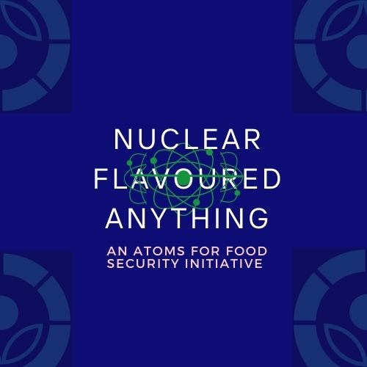

**TEAM KKV_REPUBLIC OF SOUTH AFRICA**

